SWT 22022-Practical for Internet Application Development
Department of Information and Communication Technology
Faculty of Technology
Lab sheet :08
Reg. Number: SEU/IS/20/ICT/084
Academic Year :2020/2021
Date: 2024.07.08
Practical No :08

Title:
- PHP, MySQL and JavaScript.
Aims:
• Create and read data with PHP and MySQL
• Creating a simple web application using PHP, MySQL and JavaScript
Tasks:
• Create new database
• Implement functions for store data
• Implement functions for read specific user data
• Save sessions when user login

Activities :
1. Create a new database as “expense_tracker”
2. Create a new table named “users”

CREATE DATABASE expense_tracker;
USE expense_tracker;
CREATE TABLE users (
id INT AUTO_INCREMENT PRIMARY KEY,
username VARCHAR(50) NOT NULL UNIQUE,
password VARCHAR(255) NOT NULL,
email VARCHAR(100) NOT NULL UNIQUE,
created_at TIMESTAMP DEFAULT CURRENT_TIMESTAMP
);

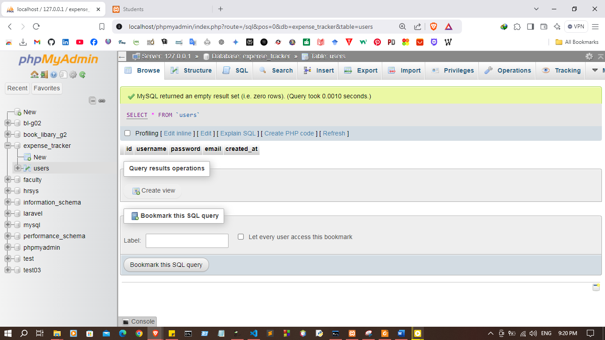
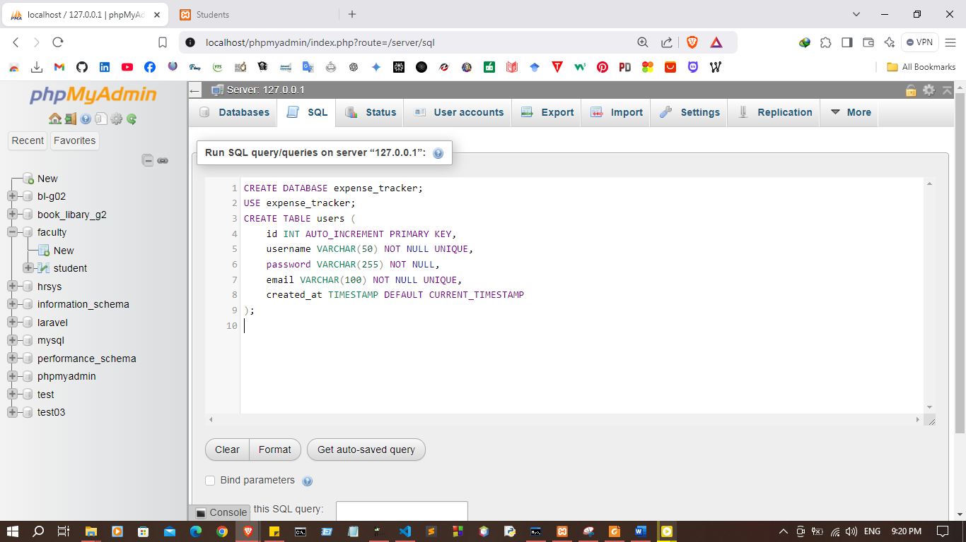

3. Implement functions for user registration
I. JavaScript
async function register() {
const username = document.getElementById('registerUsername').value;
const password = document.getElementById('registerPassword').value;
const email = document.getElementById('registerEmail').value;
const response = await fetch('php/register.php', {
method: 'POST',
body: JSON.stringify({ username, password, email }),
headers: { 'Content-Type': 'application/json' }
});
const result = await response.json();
alert(result.message);
}

II. register.php
<?php
session_start();
require_once '../database/User.php';
$database = new Database("localhost", "root", "", "expense_tracker");
$db = $database->getConnection();
$user = new User($db);
$data = json_decode(file_get_contents("php://input"));
$user->setUsername($data->username); $user->setPassword($data->password); $user->setEmail($data->email);
if ($user->register()) {
echo json_encode(["message" => "User was registered."]);
} else {
echo json_encode(["message" => "Unable to register the user."]); }
?>

4. Implement functions for user login
I. JavaScript
async function login() {
const username = document.getElementById('loginUsername').value;
const password = document.getElementById('loginPassword').value;
const response = await fetch('php/login.php', {
method: 'POST',
body: JSON.stringify({ username, password }),
headers: { 'Content-Type': 'application/json' }
});
const result = await response.json();
if (result.message === "Login successful.") {
window.location.href = 'dashboard.html';
} else {
alert(result.message);
}
}
II. login.php
<?php
session_start();
require_once '../database/User.php';
$database = new Database("localhost", "root", "", "expense_tracker");
$db = $database->getConnection();
$user = new User($db);
$data = json_decode(file_get_contents("php://input"));
$user->setUsername($data->username); $user->setPassword($data->password);
if ($user->login()) {
$_SESSION['username'] = $user->username;
echo json_encode(["message" => "Login successful."]);
} else {
echo json_encode(["message" => "Login failed."]);
}
?>
5. Implement function for logout
I. JavaScript
async function logout() {
const response = await fetch('php/logout.php', { method: 'POST'});
const result = await response.json();
if (result.message === "Logged out successfully.") {
window.location.href = 'index.html';
} else {
alert(result.message);
}
}
II. logout.php
<?php
session_start();
session_destroy();
echo json_encode(["message" => "Logged out successfully."]);
?>

Code
Database.php
<?php
class Database {
private $host;
private $username;
private $password;
private $database;
private $connection;

public function __construct($host, $username, $password, $database) {
$this->host = $host;
$this->username = $username;
$this->password = $password;
$this->database = $database;

$this->connect();
}

private function connect() {
$this->connection = mysqli_connect($this->host, $this->username, $this->password, $this->database);
if (!$this->connection) {
die("Server Error!");
}
}

public function getConnection() {
return $this->connection;
}
}
?>

Login.php
<?php
session_start();
require_once '../database/Database.php';
require_once '../database/User.php';

$database = new Database("localhost", "root", "", "expense_tracker");
$db_connection = $database->getConnection();
$user = new User($db_connection);

$data = json_decode(file_get_contents("php://input"));

$user->setUsername($data->username);
$user->setPassword($data->password);

if ($user->login()) {
$_SESSION['username'] = $user->username; // Corrected here
echo json_encode(["message" => "Login success"]);
} else {
echo json_encode(["message" => "Login fail"]);
}
?>

register.php

<?php
session_start();
require_once '../database/Database.php';
require_once '../database/User.php';

$database = new Database("localhost", "root", "", "expense_tracker");
$db = $database->getConnection();
$user = new User($db);

$data = json_decode(file_get_contents("php://input"));
$user->setUsername($data->username);
$user->setPassword($data->password);
$user->setEmail($data->email);

if ($user->register()) {
echo json_encode(["message" => "User was registered."]);
} else {
echo json_encode(["message" => "Unable to register the user."]);
}
?>

User.php
<?php
class User {
public $username;
public $password;
public $email;
public $id;

private $conn;

public function __construct($db) {
$this->conn = $db;
}

public function setUsername($username) {
$this->username = $username;
}

public function setPassword($password) {
$this->password = $password;
}

public function setEmail($email) {
$this->email = $email;
}

public function register() {
$hash_password = password_hash($this->password, PASSWORD_DEFAULT);
$query = "INSERT INTO users (username, password, email) VALUES ('$this->username', '$hash_password', '$this->email')";
$result = mysqli_query($this->conn, $query);
return $result !== false; // Return true on success
}

public function login() {
$query = "SELECT id, username, password FROM users WHERE username = '$this->username' LIMIT 1";
$result = mysqli_query($this->conn, $query);

if ($result) {
$row = mysqli_fetch_assoc($result);
if ($row && password_verify($this->password, $row['password'])) {
$this->id = $row['id'];
$this->username = $row['username'];
return true;
}
}
return false;
}
}
?>

Logout.php
<?php
session_start();
$_SESSION = [];
session_destroy();
header('Content-Type: application/json');
echo json_encode(["message" => "Logout success!"]);
?>

Index.html
<!DOCTYPE html>
<html lang="en">
<head>
<meta charset="UTF-8">
<meta name="viewport" content="width=device-width, initial-scale=1.0">
<title>User Login and Registration</title>
<!-- Bootstrap CSS -->
<link rel="stylesheet" href="https://stackpath.bootstrapcdn.com/bootstrap/4.5.2/css/bootstrap.min.css">

<script>
async function login() {
const username = document.getElementById('loginUsername').value;
const password = document.getElementById('loginPassword').value;

const response = await fetch('php/login.php', {
method: 'POST',
body: JSON.stringify({ username, password }),
headers: { 'Content-Type': 'application/json' }
});

const result = await response.json();
if (result.message === "Login success") {
window.location.href = "dashboard.html";
} else {
alert(result.message);
}
}

async function register() {
const username = document.getElementById("registerUsername").value;
const email = document.getElementById("registerEmail").value;
const password = document.getElementById("registerPassword").value;

const response = await fetch('php/register.php', {
method: 'POST',
body: JSON.stringify({ username, email, password }),
headers: { 'Content-Type': 'application/json' }
});

const result = await response.json();
alert(result.message);
}

function showRegistration() {
document.getElementById('registration').style.display = 'block';
document.getElementById('login').style.display = 'none';
}

function showLogin() {
document.getElementById('registration').style.display = 'none';
document.getElementById('login').style.display = 'block';
}
</script>
</head>
<body class="bg-light">

<div class="container mt-5">
<div class="mb-3 d-flex justify-content-center">
<button class="mr-2 btn btn-primary" onclick="showRegistration()">Register</button>
<button class="btn btn-secondary" onclick="showLogin()">Login</button>
</div>

<div id="registration" class="p-4 shadow-sm card" style="display: none; max-width: 400px; margin: auto;">
<h2 class="text-center">Registration</h2>
<div class="form-group">
<label for="registerUsername">Username</label>
<input type="text" class="form-control" id="registerUsername" placeholder="Username" required>
</div>
<div class="form-group">
<label for="registerEmail">Email Address</label>
<input type="email" class="form-control" id="registerEmail" placeholder="Email Address" required>
</div>
<div class="form-group">
<label for="registerPassword">Password</label>
<input type="password" class="form-control" id="registerPassword" placeholder="Password" required>
</div>
<button class="btn btn-success btn-block" onclick="register()">Register</button>
</div>

<div id="login" class="p-4 shadow-sm card" style="display: block; max-width: 400px; margin: auto;">
<h2 class="text-center">Login</h2>
<div class="form-group">
<label for="loginUsername">Username</label>
<input type="text" class="form-control" id="loginUsername" placeholder="Username" required>
</div>
<div class="form-group">
<label for="loginPassword">Password</label>
<input type="password" class="form-control" id="loginPassword" placeholder="Password" required>
</div>
<button class="btn btn-primary btn-block" onclick="login()">Login</button>
</div>
</div>

<!-- Bootstrap JS and dependencies (jQuery and Popper.js) -->
<script src="https://code.jquery.com/jquery-3.5.1.slim.min.js"></script>
<script src="https://cdn.jsdelivr.net/npm/popper.js@1.16.1/dist/umd/popper.min.js"></script>
<script src="https://stackpath.bootstrapcdn.com/bootstrap/4.5.2/js/bootstrap.min.js"></script>
</body>
</html>

dashboard.html
<!DOCTYPE html>
<html lang="en">
<head>
<meta charset="UTF-8">
<meta name="viewport" content="width=device-width, initial-scale=1.0">
<title>Dashboard</title>
<!-- Bootstrap CSS -->
<link rel="stylesheet" href="https://stackpath.bootstrapcdn.com/bootstrap/4.5.2/css/bootstrap.min.css">

<script>
async function logout() {
const response = await fetch('php/logout.php', {
method: 'POST',
headers: { 'Content-Type': 'application/json' }
});
const result = await response.json();
if (result.message === "Logout success!") {
window.location.href = "index.html";
} else {
alert("Error logging out. Please try again.");
}
}
</script>
</head>
<body class="bg-light">
<div class="container mt-5 text-center">
<h1>Welcome to the Dashboard</h1>
<p class="lead">You are now logged in.</p>
<button class="mt-3 btn btn-danger" onclick="logout()">Logout</button>
</div>

<!-- Bootstrap JS and dependencies -->
<script src="https://code.jquery.com/jquery-3.5.1.slim.min.js"></script>
<script src="https://cdn.jsdelivr.net/npm/popper.js@1.16.1/dist/umd/popper.min.js"></script>
<script src="https://stackpath.bootstrapcdn.com/bootstrap/4.5.2/js/bootstrap.min.js"></script>
</body>
</html>

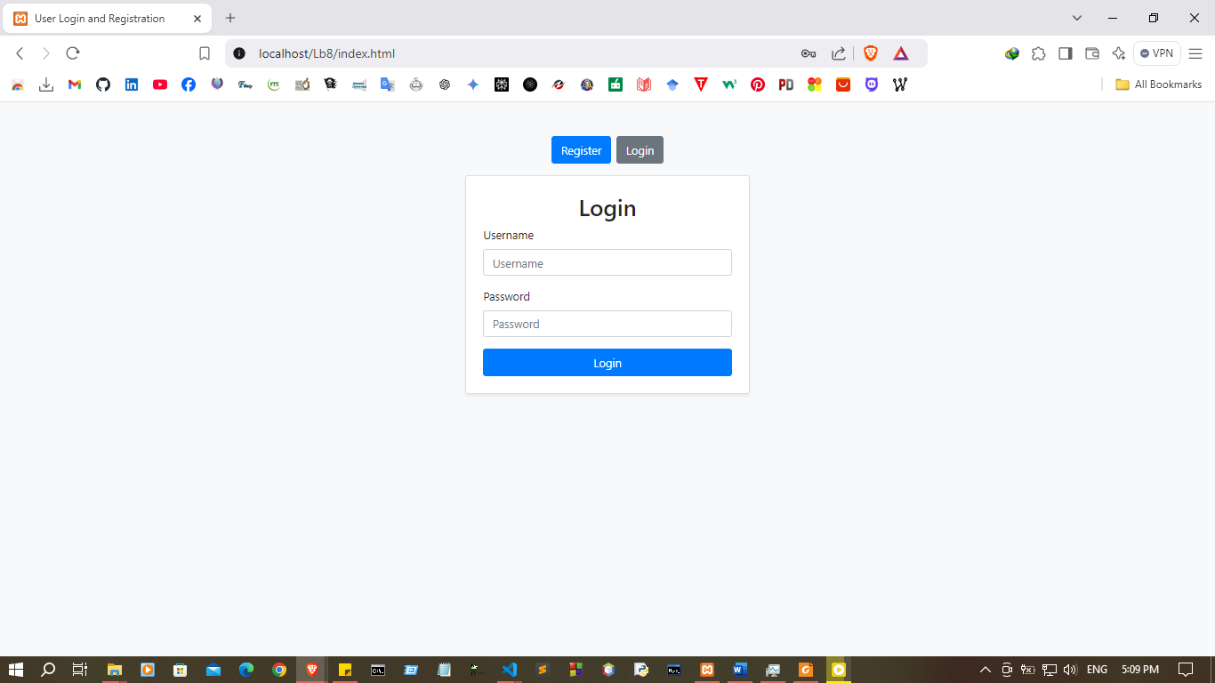
OUTPUT
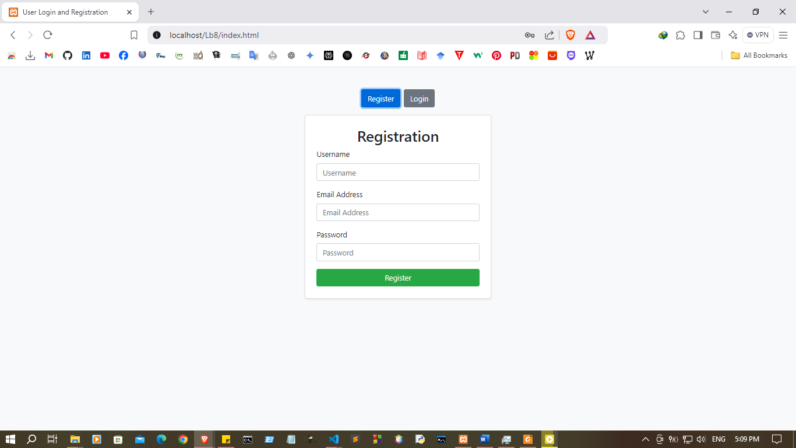
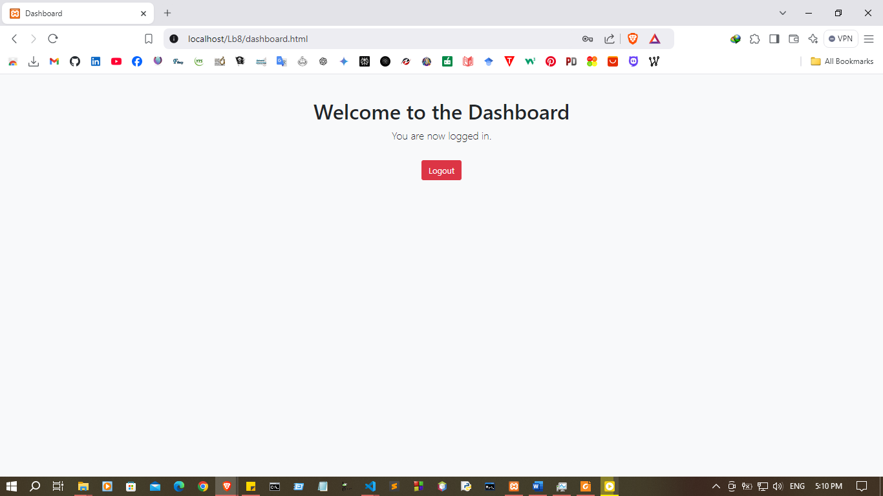
Discussion:
- In this lab practical session, I focused on developing a basic web application using PHP, MySQL, and JavaScript, with the main objective of understanding how these technologies work together to handle data and manage user sessions. First, I created a new MySQL database to store user information, which allowed me to practice setting up tables and defining data structures. Next, I implemented PHP functions to insert and retrieve data from the database, gaining hands-on experience with SQL queries for storing and accessing specific user data. This involved using PHP to communicate with MySQL, a crucial skill for backend development. I also worked on implementing a session management system, which allows users to log in and keep their session active as they navigate the web application. Finally, I integrated JavaScript for interactive elements, enhancing the user experience by providing dynamic, responsive feedback on the frontend. This session helped solidify my understanding of the interplay between these technologies in a real-world web application.

